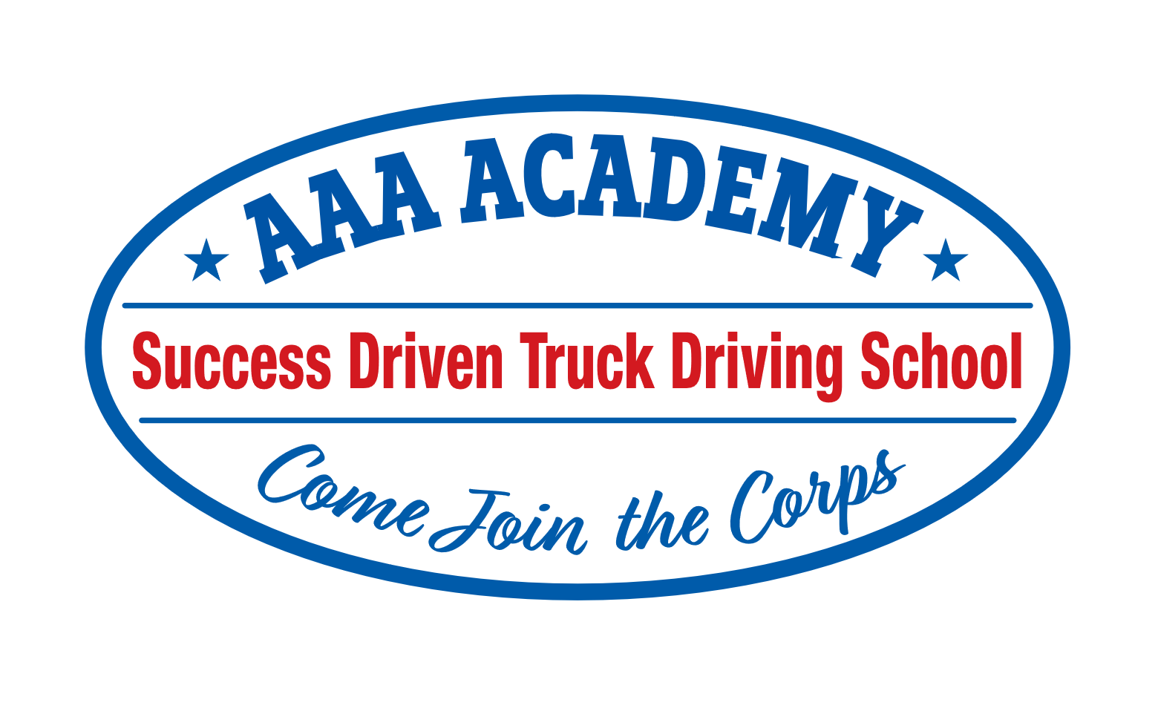
www.aaaacademyllc.com
7000 Button Ln. Dixon, CA 95620
__________________________________________
SCHOOL CATALOG
CLASS A COMMERCIAL DRIVER TRAINING PROGRAM
Period Covered: September 1, 2026 – December 31, 2026

REVISED: DECEMBER 2025

TABLE OF CONTENTS
About AAA Academy, LLC…………………………………………………………………..………….1
APPROVAL STATEMENT……………………………………………………………………..……....1
PROGRAM DESCRIPTION….………………………………………………………………..….........2
Phase One………………………………………………………………………………………………….2
Phase Two….……………………………………………………………………………………….……..2
Phase Three………………………………………………………………………………………………..2
AAA Academy Mission Statement and Objectives………………...……………………………..........3
STUDENT APPPLICANT ADMISSION AND QUALIFICATION REQUIREMENTS…………,..3
DOT Physical and Drug Screen…………………………………………………………………….……,.3
High School Diploma, GED or Equivalent……………………………..………………………………..,.3
Class B or C Driver License………..……………………………………………………………………,..3
Identification………………………………………………………………………………………………,3
AAA ACADEMY ADMISSION POLICIES…………………………………………………………..,4
Tuition…………………………………………………………………………………………………..,..4
Credits or Units Earned or Transferred……………………………………………………………….,4
NOTICE CONCERNING TRANSFERABILITY OF CREDITS AND CREDENTIALS EARNED AT OUR INSTITUTION……………………………………………………………………………….,.4
Commercial Driver Licensure……………..……………………………………………………………5
AAA ACADEMY, LLC FACULTY………………………………………………………………….6/7
Cancellation, Withdrawal and Refund Policies……………………..…………………………………8
STUDENT’S RIGHT TO CANCEL……………………………………………………………………8
Refund Policy……………………………………………………………………………………………..8
Refund for Students Who Receive Federal Funds…….…………………………………….....................8
Pro-Rated Refunds…..……………………………………………………………………………………8
Pro-Rated Daily Rate……….…………………………………………………………………………….8
Pro-Rated Refund Calculation………………………………………………………………………........8
Refund Calculation Example…………...………………………………………………………………...8
Requested and De Facto Withdrawal……………………………………………………………………….9
STUDENT CONDUCT………………………………………………………………………….…….….9
Federal Financial Aid Programs………………………….……………………………………………….10
Attendance Policies……….……………………………………………………………………………….10
Leave-of-Absence…………………………………………………………………………………………10
Probation and Dismissal Policies………………………………………………………………………….10
Students Right and Grievances……………………………………………………………………………11
EQUAL OPPORTUNITY POLICY……………………………………………………………………11
AAA Academy Grievance Review and Consideration Process…………………...……………….11/12
TOTAL INSTITUTIONAL CHARGES……………………………………………………………12/13
Federal, State AND Local Financial Aid Programs……………………………………………………….13
Additional Clauses from AAA Academy Enrollment Agreement………………………………….....14
Bankruptcy……………………………………………………………………………………………….14
Placement Services……………………………………………………………………………………….14
Student Tuition Recovery Fund……………………………………………………………………..15/16
Accreditation……………………………………………………………………………………………..16
Language Proficiency and Foreign Students…………………………………………………….…..…16
Facilities and Equipment…………………………………………………………………………...........17
AAA Academy Training Room & Library… ………………………………………………………18/19
Skills Range Area…………………………………………………………………………………….…..18
Student Services………………………………………………………………………………..………..................19
Housing Information……………………………………………………………………………….….…19
Student Records Policy………………………………………………………………………………..…19
Background…………………………………………………………………………………………….....20

Greetings: AAA Academy Applicant
AAA Academy LLC, its faculty and management welcome you to our Commercial Driver License (CDL) (CLASS A) Vocational Training School. We have a comprehensive CDL training program designed to help you learn the rules and skills required to pass the Department of Motor Vehicles (DMV) permit, oral and drive tests. More importantly, your training will include practical application driver skills training that will help prepare you for a career as a professional driver.
APPROVAL STATEMENT
AAA Academy is a private Vocational Training School with the approval to operate on April 2, 2019 as a “non-accredited” institution, granted by the Bureau for Private Postsecondary Education (BPPE) in the state of California. BPPE is a division of the State of California Department of Consumer Affairs. Approval to operate means that the institution is compliant with the minimum state standards as set forth in the CEC and 5, CCR.
Please review all the information within this catalog. It is important that you understand the full scope of our vocational training program, so you can make an informed decision whether to enroll in our school or not. AAA Academy is a Success Driven Truck Driving School. Our commitment to your success must be matched by your personal commitment to work hard to learn the material and skills we teach so you can earn your Commercial Driver License (CDL). Toward this successful result, we thank you for your interest and bid you good fortune with your studies.
Any questions a student may have regarding this catalog that have not been satisfactorily answered by the institution may be directed to the Bureau for Private Postsecondary Education at 1747 N. Market Blvd. Ste 225 Sacramento, CA 95834, www.bppe.ca.gov , (916) 574-8900 (Phone), (916) 263-1896 (fax).
This catalog is updated at least annually, and revisions or addendums are made throughout the year as needed. A copy of the catalog may be obtained by contacting our Admissions Representative at our Campus. A copy of our catalog is available online at www.aaaacademyllc.com . It is the policy of AAA Academy that each prospective student receives a catalog and applicable addenda and is encouraged to review this information prior to signing an Enrollment Agreement. The Admissions Representative is responsible for providing the catalog to the prospective student. The student shall initial the Enrollment Agreement acknowledging that he/she has received the catalog.
As a prospective student, you are encouraged to review this catalog prior to signing an enrollment agreement. You are also encouraged to review the School Performance Fact Sheet, which must and will be provided to you prior to signing an enrollment agreement.
A student or any member of the public may file a complaint about this institution with the Bureau for Private Postsecondary Education by calling (888) 370-7589 or by completing a complaint form, which can be obtained on the Bureau's Internet Web site: www.bppe.ca.gov
The Office Of Student Assistance and Relief is available to support prospective students, current students or past students of private postsecondary educational institutions in making informed decisions, understanding their rights, and navigating available services and relief options. The office may be reached by calling Toll-Free (888)370-7589 or by visiting Web site Address: www.osar.bppe.ca.gov

Classes are held at the AAA Academy facility, located at 7000 Button Ln. Dixon, CA 95620. Phone: (707) 679-5950. Web site: www.aaaacademyllc.com.

PROGRAM DISCRIPTION
AAA Academy, LLC provides vocational training to assist students to obtain a Class A Commercial Driver License (CDL) Tractor with Trailer in a 4-Week (20 Day) - 150 Clock Hour Program. A Clock Hour is 50 contact minutes per hour. As required the Federal Motor Carrier Safety Administration (FMCSA) Entry-Level Driver Training (ELDT) meets the minimum regulation requirements as set forth in the Entry-Level Driver Training Regulations 49 CFR 380.353. The curricula will prepare you for the Department of Motor Vehicles CDL oral, skills and practical drive tests. Licensure will qualify you for employment as defined by the US Department of Labor’s Standard Occupational Classification as a Heavy and Tractor-Trailer Truck Driver (Labor Code 53-3032).
Phase One Federal Motor Carrier Safety Administration (FMCSA) Entry-Level Driver Training (ELDT). After detailed theory instruction in five (5) prescribed areas, you will be tested. The minimum passing score is 80%. Mandated per FMCSR 49 CFR 380.503
Phase Two of our training focuses on the process and the language of the Pre-Trip vehicle and trailer inspection as well as the air brakes system. It is critical to your success that you learn the components and inspection process. This is important, not just to pass the DMV tests, but because this material is about the systems of the truck and trailer you will use as a professional driver. Knowing the system components and being able to identify if they are serviceable or failing, is the essence of safety and safe operations as a professional driver. As with all AAA Academy tests, you will be tested to the same standards in the same method DMV uses. A passing performance on the Pre-Trip Inspection is 80%. You are required to pass the Air Brakes test with a perfect 100% score.
Phase Three FMCSA ELDT minimum requirements: Public Roadway (10) hours. Range Skills (5) hours. The training focuses on basic road skills and vehicle operations. Here you will learn how to safely operate and drive a Class A truck with trailer. You will learn the basic driving skills you will be required to demonstrate to the DMV, including a forward stop, straight line backing, forward offset tracking and reverse offset backing. You will be tested on these driving skills by AAA Academy to the same standard of performance DMV will require you to perform to, which is; no more than 8 points accumulated. In addition to learning these exercises, you will get on-road, real driving experience with our licensed driving instructors. This Real-World experience will put everything you learn into perspective. Throughout Phase Two and Three training, you will be subject to pop-quizzes and weekly tests to demonstrate your knowledge and understanding of the material. The results of these tests also help focus our instructors toward where you need to improve and where we need to concentrate additional training. Before your final DMV oral, skills and practical driving test, AAA Academy instructors will perform a complete simulated DMV-style test to define your knowledge of the material and reduce testing anxiety. All students will learn to drive a manual transmission (10-Speed) Truck. If a student is, not able to safely operate the 10-speed truck they may be placed in an automatic truck for their test with DMV. If this occurs the student will have a restriction on their CDL that only allows them to drive automatic Class A vehicles.
Please note: no credits, units or hours of training can be taken (transferred) to another CDL Training Institution. The hours required to complete this training may vary with your ability to grasp and understand the concepts and practice of the material. On average, students are ready with 140-hours of training. Other students require more time to be fully prepared. After 150 hours, your training is considered complete.
AAA Academy Mission Statement and Objectives
Mission Statement:
AAA Academy is committed to providing vocational training to help people obtain their Class A Commercial Driver License (CDL) and Driving Endorsements from the California Department of Motor Vehicles.
Program Objectives:
- Through range and behind-the-wheel instruction, student drivers will obtain a Class A Commercial Driver License (CDL).
- Upon licensing, AAA Academy will help the new student driver find employment to enable them to get their initial operating experience and haul commercial loads for compensation.
a. Button Transportation, Benjamin’s Transfer and Castle & King will be the primary hiring companies.
b. AAA Academy will also work with other driver employers to help with placement.
Student Applicant Admission and Qualification Requirements
Commercial Learners Permit (CLP). All candidates wishing to attend AAA Academy must first obtain a Commercial Learners Permit (CLP) from the Department of Motor Vehicles prior to enrollment.
DOT Physical and Drug Screen. Applicants to AAA Academy will be required to pass a Department of Transportation (DOT) Physical and Drug test before being accepted into the program. The DOT Physical and Test are mandated by both the FMCSA and the State of California. The Drug Policy is mandated by the FMCSA. AAA Academy is enrolled in a Random Drug testing Consortium.
High School Diploma, GED, or equivalent education. The possession of a High School, GED or taking an Ability to Benefit Exam has been repealed per AB 607 effective 1/1/2022. AAA Academy, LLC will not admit any student who is obviously unqualified or who does not appear to have a reasonable prospect of completing the program. A student driver must be able to read, write and converse in English. Consequently, all transactions are performed in English only. AAA Academy, LLC does not provide recruitment or training in any other languages.
Class B or C Driver License. For a student to obtain a Class A Commercial Driver License (CDL), the Department of Motor Vehicles requires the applicant to have a valid and unrestricted Class B or C License. AAA Academy also requires student applicants to provide an H-6 Ten Year Driver Record form from DMV. In the event a prospective student does not have a Class B or C license or has a poor driving record (for example, a recent DUI or unsafe driving citations), their application will not be accepted.
Identification. The Department of Motor Vehicles requires specific personal documents for an applicant to become a licensed driver. This includes a valid Birth Certificate as well as Driver License, United States passport or California Identification card as well as proof of California residency. If an applicant cannot provide these documents, their application will not be accepted.

AAA Academy Admission Policies
AAA Academy holds the following policies and practices relating to all applicants and students. In no case will these policies and practices be deviated from without specific review and unanimous agreement by the AAA Academy Board of Directors.
Tuition. Student applicants to AAA Academy for Commercial Driver License Training are responsible for tuition payment in full upon the successful completion of their DMV Skills and Driving Test and have received the CDL. Payment in full shall be made within 45 Days of the date of invoice either through direct payment, vocational training funding by a third-party institution or by means of a third-party scholarship. Private pay student applicants shall make payment in full at the first date of attendance.
Credits or Units Earned or Transferred. AAA Academy’s Vocational Commercial Driver License Training program does not earn or otherwise generate credits or units that can be transferred to any other institution. Furthermore, no credits or units will be accepted from any institution for any manner of training. AAA Academy has no manner of articulation or transfer agreement with any institution.
NOTICE CONCERNING TRANSFERABILITY OF CREDITS AND CREDENTIALS EARNED AT OUR INSTITUTION. The transferability of credits you earn at AAA Academy, LLC is at the complete discretion of an institution to which you may seek to transfer. Acceptance of the certificate you earn in the Commercial Driver Training Program is also at the complete discretion of the institution to which you may seek to transfer. If the Certificate that you earn at this institution are not accepted at the institution to which you seek to transfer, you may be required to repeat some or all your coursework at that institution. For this reason, you should make certain that your attendance at this institution will meet your educational goals. This may include contacting an institution to which you may seek to transfer after attending AAA Academy to determine if your certificate will transfer.

Commercial Driver Licensure
As noted above in Program Description, you will be exposed to a great deal of information to help prepare you for the DMV final practical tests for Commercial Driver Licensure. AAA Academy, its instructors and management will work hard to help you learn and understand all, of the concepts and skills you will need to demonstrate knowledge with DMV testing in order, to become a licensed Class A Commercial Driver. AAA Academy makes no claim or promise, that on completion of our training program you will pass these tests. We will diligently work to prepare you for these tests, but you alone are responsible for your performance in these tests.
Relating to the DMV Skills and Drive Test, which includes the oral, skills and practical drive tests, the DMV gives the student three attempts to pass this test. In the event of a failed first or second attempt to pass the final DMV test, AAA Academy will continue to work with the student in areas where they need improvement (on areas where they failed) to hopefully pass on their third and final attempt. In the event of a third failure, the student will be released from AAA Academy’s training program. The student may reappoint with DMV independently or through another training institution for additional attempts to pass the final drive test. However, AAA Academy will no longer provide the student training after the third failure to pass the DMV final test. In the event of a retest, the student will be responsible for all DMV retest fees.
With regards to a student with prior experiential learning, AAA Academy Staff will do an assessment of the experience. There will however, be no modification of the curriculum. The amount of training time may be modified at the discretion of staff and the agreement of the student.
DMV Minimum Performance Levels for Testing
Written Permit Test 80% Correct
Pre-Trip Test 80% Correct
Air Brakes Test 100% Correct
Skills Test No more than 8 Points
Practical Test Drive No more than 30 points*

* No Automatic Failure Violations/Critical Error

Federal Motor Carrier Safety Regulations
Minimum Requirements
Theory (35) Chapters 80% Correct
Behind the Wheel – Public Roadway 10 Hours Minimum
Behind the Wheel – Range 5 Hours Minimum

AAA Academy Faculty
Bob Button—Owner/Instructor

Job Duties and Responsibilities: To develop, refine and provide classroom training. This includes student counseling services and guidance throughout the training process.
Resume Summary: Bob Button is the founder and leader of Button Transportation, established 1977. Bob started the company as a one-man, one-truck operation to put food on the family table. Today, Button Transportation, Inc and LLC operate hundreds of trucks and a thousand trailers with local, west coast regional and national commodity transportation services. Over his four-plus decades as a trucking company owner, Bob has done every job in the company from driving to book keeping, to mechanic to salesman to operations and dispatch. Bob has also trained hundreds of people to help them get their CDL and to become professional, safe drivers. Bob Button’s reputation and credibility in the industry is well-known.
Bob Button’s participation in AAA Academy as an instructor is in part to help the school grow and develop, but also to stay connected with the educational needs of students as well as industry requirements and changes.

Sanford (Sam) Anderson
Chief Academic Officer/ Instructor
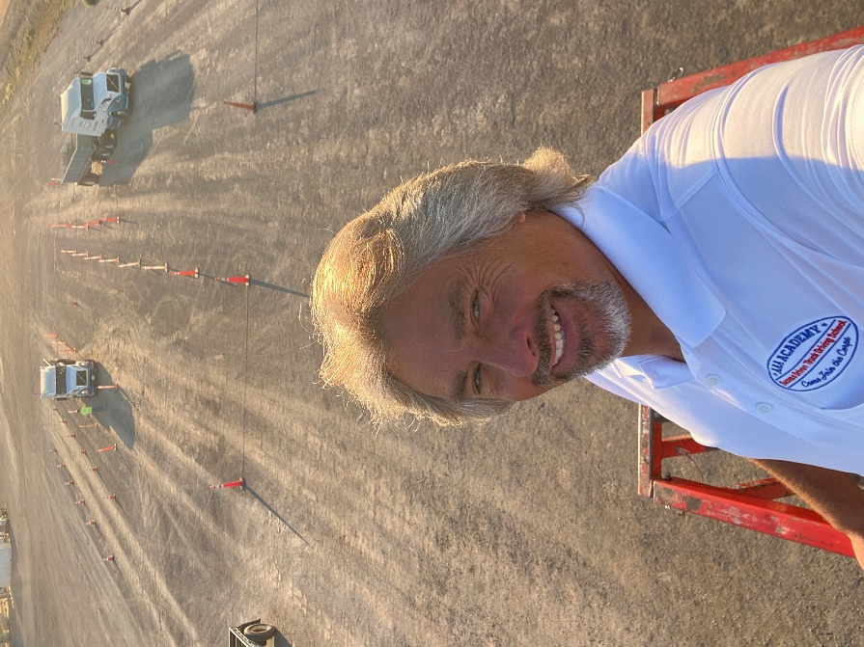
Job Duties and Responsibilities: To develop, refine, provide all class-room and field training as well as logistics coordination with students for DOT Medical, Drug Testing and DMV testing. This will also include student counseling services and guidance throughout the training process. Sam oversees all aspects of AAA Academy academic functions, including the development of curriculum and class scheduling as well as working closely with his team of Instructors. Sam is the key interface between AAA Academy and Button Transportation to on-board newly trained Commercially Licensed Drivers. Additionally, he is the liaison with California Employment Development Agencies and private parties for student enrollment.
Resume Summary: Sam Anderson started operating heavy equipment at a young age, growing up on a small family farm. He drove and learned to maintain dump trucks, flatbeds with trailers and other heavy equipment before finding work in his early adulthood, learning the electrical, plumbing and construction trades. Sam began his association with Button Transportation in the early 2000s as a self-employed telecommunications contractor, designing and maintaining our phone and information technology hardware and systems. In 2020, Sam earned his CDL, expanding his experience in one of the most demanding and safety sensitive commercial driving environments, the logging industry. In his trucking career, Sam demonstrated remarkable leadership skills and comes to AAA Academy LLC with the knowledge to teach students how to become safe, professional commercial driers. What is more, Sam Anderson is a great person and a natural team leader with a vision for success. Sam joined the AAA Academy team in the spring of 2026 as our new Chief Academic Officer and Instructor.

Duane Foster—Instructor

Job Duties and Responsibilities: To develop, refine and provide; assistance to students in the classroom and field training.
Resume Summary: Duane Foster holds a Bachelor of Science degree in Criminal Justice, one class short of a Master’s Degree. Duane is a United States Army Certified Instructor. Duane was employed with Button Transportation as a Mentor Driving Instructor, providing job specific driver training for new Class A drivers hired at Button Transportation. Duane Foster has 25 years of experience in the trucking industry with Button Trans.

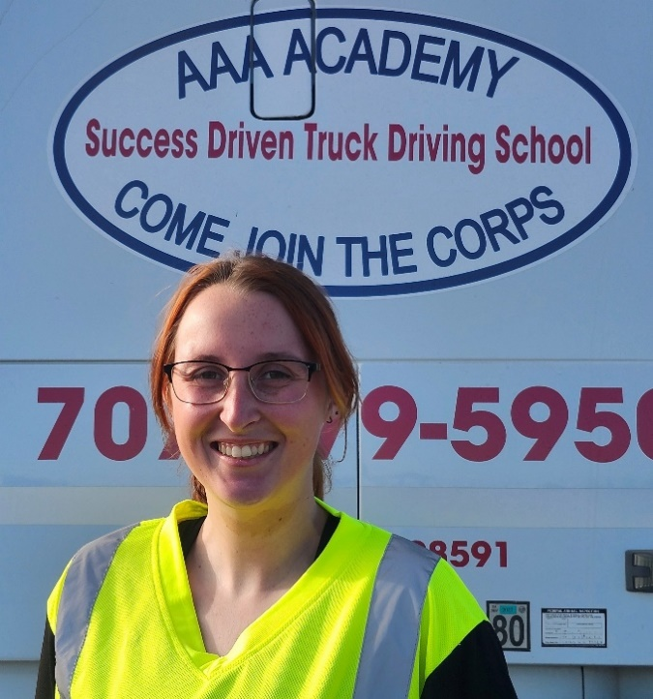
Emily Wilson—Yard Instructor
Job Duties and Responsibilities: To develop, refine and provide; assistance to students in the classroom and field training.
Resume Summary: Emily Wilson holds three Associate degrees in Criminal Justice, Welding Technology and Fire Science, earned while maintaining a 4.0 GPA on the Dean’s List. After college, Emily attended Fire Academy, an intensive 5-day per week, 12-hour per day schedule for 6-months. Emily also taught MIG, TIG and Stick Welding for structural and fabrication applications. Emily earned her CDL in 2025 and went to work hauling loads with Benjamin’s Transfer, where she excelled. With her remarkable academic experience, her teaching background and her passion for trucking, Emily joined the AAA Academy team in the summer of 2026 as a Yard Instructor, teaching and supporting all aspects of pre-trip, airbrakes and skills instruction. Emily is a high-energy yard instructor with a remarkable ability to help our students understand the depth and breadth of the curriculum.

Cancellation, Withdrawal and Refund Policies
STUDENT'S RIGHT TO CANCEL. An enrolled student has the right to cancel the enrollment agreement and obtain a refund of charges paid through attendance at the first, class session or the seventh day after enrollment, whichever is later. Notice of Cancellation/Withdrawal shall be in writing, presented in person, by delivery service such as the United State Postal Service, by fax or through email. Written Notice of Withdrawal/Cancellation may be effectuated by written notice or by the student’s conduct, including but not limited to a student’s lack of attendance. Written Notice of Cancellation/Withdrawal must be dated and signed by the student with the date Cancellation/Withdrawal is effective, which shall be no later than the date received by the institution. Notice of Cancellation must be sent to the attention of AAA Academy via delivery service to 7000 Button Lane, Dixon, California 95620, via fax to 707 678 7433 by or via email to Lew Altomare, lew@aaaacademyllc.com.
1. Refund Policy. AAA Academy LLC shall refund the student’s tuition payment on a pro-rated basis through the completion of 60% of the scheduled days of training. Once 60% of the schedule training days are completed, no refund will be granted. Refund payments will be made payable to the issuer of payment by check within Fourteen (14) days of receipt of a written, signed, and dated notification of the student’s desire to cancel.
2. Refunds for Students Who Receive Federal Funds. If the student has received federal student financial aid funds, the student is entitled to a refund of moneys not paid from federal student financial aid program funds. In other words, a student may receive a refund for monies that were paid by the student, not from local, state, or federal funds. Fees and tuitions that qualify for refund that were paid by local, state, or federal funds will be paid back to those institutions directly using the same pro-rating calculation defined in Pro-Rated Refunds below.
3. Pro-Rated Refunds. Refunds will be paid to when student withdrawal notice is submitted or when there is a de facto withdrawal, as outlined below, provided 60% or few of the scheduled training days are completed. The pro-rated refund is equal to the total amount paid by the student for the portion of the educational program less the amount of training the student was provided. The value of the training provided and the refund amount is based on a pro-rated daily rate of the training. Please consider the example below.
a. Pro-rated Daily Rate. The pro-rated daily rate is the total training program cost paid to the institution, divided by the number of days in the training program. Example: If the training program total cost is $6,000.00 and there are 20 scheduled days of training, the daily pro-rated would be $300.00 per day.
4. Pro-rated Refund Calculation. The pro-rated refund a student will be paid is equal to the total amount paid by the student, less the total of training days the student attended times the pro-rated number of scheduled days of training the student attended or was scheduled to attend before notice of withdrawal.
a. Refund Calculation Example. For a 20-day training with tuition of $6,000.00, the pro-rated daily rate would be $300.00 per day. If the student withdraws from the program on the twelfth (12th) day of scheduled training, the refund amount would equal to the $6,000.00 tuition cost, less the pro-rated daily rate times the eight (8) days left in the training program the student did not attend, which is $300.00 times eight (8), equaling $2,400.00. In this example, the student would be entitled to a refund of $2,400.00 (eight days of scheduled training (Not Used) times the daily pro-rated amount of $300.00). It follows that the student received twelve (12) days of training, the value of which is calculated by multiplying the pro-rated daily rate by twelve (12), which is $3,600.000.
5. Requested and de facto withdrawal. A student who requests withdrawal from the training program may do so as outlined above. In the event a student no longer comes to class, without communication to the institution (such as a request to postpone or otherwise delay training) for a period of 3 consecutive days, AAA Academy may consider the student withdrawn by conduct from the training program. In determining the amount of refund, the date of the student’s withdrawal shall be deemed the last date of recorded attendance. In determining when the refund must be paid, the student shall be deemed to have withdrawn effective at the end of the 3 consecutive days of non-attendance. Refunds will be paid, as outlined above, provided 60% or less of the training program is completed.
6. If an institution has collected money from a student for transmittal on the student's behalf to a third party for a bond, library usage, or fees for a license, application, or examination and the institution has not paid the money to the third party at the time of the student's withdrawal or cancellation, the institution shall refund the money to the student within 45 days of the student's withdrawal or cancellation.
7. An institution shall refund any credit balance on the student's account within 45 days after the date of the student's completion of, or withdrawal from, the educational program in which the student was enrolled. For purposes of clarification, "day" means calendar day.
STUDENT CONDUCT
Certain standards of conduct must be observed in, order to create a healthy and safe learning environment. Each student is given a copy of the Rules and Regulations when they start class. We ask that all students follow the rules and any direction given by staff. Students are to conduct themselves in a way that is a credit to them, their school, fellow students, and the trucking industry.
The following activities at or around the facilities and equipment will be cause for immediate termination:
- The use of, or being under the influence of alcohol and/or drugs. AAA Academy participates in an active DOT Random Program for Drug and Alcohol testing.
- Smoking in unauthorized areas
- Gambling
- Excessive absence or tardiness
- Making threats or any physical or verbal conflict with other students, staff members and/or the General public.
- Unsafe operation of equipment and/or abuse of equipment.
- Unauthorized truck starting or operation.
- Having weapons on campus or in our trucks at any time.
Federal Student Financial Aid Programs. In the event of a student participated in a Federal financial aid program to fund his or her vocational training and is dismissed from this training, AAA Academy will advise the student with a notice of cancellation in writing. A withdrawal may also be effectuated by the student's written notice or by the student's conduct, including, but not necessarily limited to, a student's lack of attendance.
AAA Academy will provide a pro rata refund of nonfederal student financial aid program moneys paid for institutional charges to students who have completed 60 percent or less of the period of attendance. In the case of Federally funded students only, AAA Academy will refund 100 percent of the amount paid for institutional charges, less a reasonable deposit or application fee of $250, if notice of cancellation is made through attendance at the first, class session, or the seventh day after enrollment, whichever is later.
Attendance Policies. Student attendance and timeliness are critical to the learning process. Students must attend all scheduled classes and be on-time. There is a great deal of information to review, learn and master as well as skills one must gain to become a Commercially Licensed Driver. Missing class and showing up late to class is disrespectful to the instructors and other students, just as it jeopardizes your ability to learn what is necessary to earn your CDL. Should a student be consistently late to class, upon the third tardiness he or she will be formally counseled and warned that their training will be terminated if the behavior continues. This warning will begin the student’s probationary warning. The probationary warning will be in writing and delivered to the student before the conclusion of the business day in which the warning was given. Should the behavior continue, AAA Academy will discontinue his or her training. A letter of discontinuance will be given to the student, documenting the inappropriate behavior as well as the probationary warning. No refund will be given beyond what is outlined above in Refund Policy.
Leave-of-Absence Policies. There are times when life events may get in the way of one’s training. AAA Academy understands this. Family emergencies, work schedules and illnesses are some of the reasons a student may not be able to continue their training consecutively. In these cases, AAA Academy will extend a leave-of-absence option to the student in writing. The student will be given the option of discontinuing training for up to 12-months from the date of discontinuance, with the option to begin training anew. AAA Academy offers one leave-of absence to any given student. A leave of absence is not a justification for tuition reimbursement. Should a student decide that proceeding with the training is not possible upon completion of the 12th-month of their leave of absence, that student will receive a tuition refund as outlined above in sections one through four: 1) Refund Policy, 2) Refunds for Students Who Receive Federal Funds, 3) Pro-Rated Refunds, and 4) Pro-rated Refund Calculation.
Probation and Dismissal Policies. AAA Academy is a professional training institution and place of business. All parties, students, instructors, and administrators, are expected to conduct, themselves professionally and respectfully at, all times. Behavior that is contrary to standards of professional business contact will not be tolerated. In the event a student behaves inappropriately, he or she will be immediately formally counseled and warned that their training will be terminated if the behavior continues. This warning will begin the student’s probationary warning. The probationary warning will be in writing and delivered to the student before the end of the business day in which it occurred. Should the inappropriate behavior continue AAA Academy will discontinue his or her training. A letter of discontinuance will be given to the student, documenting the inappropriate behavior as well as the probationary warning. Tuition refund will be in accordance with AAA Academy Refund Policy.

- An Attendance Dismissal will occur upon the third day a student fails to come to class without contacting the school
- A Progress Dismissal will occur when a student fails to meet Testing Standards in one or more of the following categories.
- Student fails to pass Air Brake Test and In-Cab Inspection: End of Week - 1
- Student fails to pass Pre-Trip Inspection Test: End of week - 3
- Student fails to pass Backing Skills Test: End of week- 3
- Student fails to pass Public Roadway Drive Test: End of week - 3
Students Rights and Grievances. In the event a student has a problem, question or concern about AAA Academy policies or specific actions taken relating to student discipline, probation or dismissal, the student is welcome to inquire and appeal to AAA Academy’s Board of Directors to review the issue. This inquiry or appeal must be in writing. It must clearly state the issue, the action taken against the student (probation and/or dismissal) and the reason the action was with the student. The appealing student must also present a statement of facts that support why the action is unjust. In some cases, the Board of Directors may invite the student to present his or her appeal personally, but only after the written inquiry or appeal is submitted for Board review. The written inquiry or appeal must be mailed to AAA Academy’s corporate headquarters, attention Chief Academic Officer via 7000 Button Lane, Dixon, California 95620.
EQUAL OPPORTUNITY POLICY
AAA Academy grants students of any race, color, creed, sex, marital status, sexual orientation, nationality, and ethnic origin. All rights, privileges, programs, and activity generally accorded or made available to students at our school. We do not discriminate on the bases of race, color, creed, sex, nationality, or ethnic origin in administration of our educational policies and admissions policies. If you believe you have been subjected to discrimination you have the right to file a complaint regarding the alleged violation. Individuals with disabilities are encouraged to visit the school to determine if the facilities are adequate for their needs and/or if the training offered will be beneficial for them.
AAA Academy Grievance Review & Consideration Process.
AAA Academy exists to help people earn their Class A Commercial Driver License (CDL) so they can become employed as professional truck drivers. In this, our instructors and administration personnel are professionals; we act like professionals; we treat our students like professionals; and, we expect to be treated professionally. There are times in life when, well intentioned persons do not see eye to eye. The spirit of AAA Academy’s grievance process is that we will recognize these situations for what they are, discuss the situation with all concerned parties and come to a mutual understanding among professionals that renders a fair and balanced resolution to a problem or conflict.
In the event of a student grievance, AAA Academy’s Governing Board will open the matter to a formal grievance review and consideration process. That process shall be as follows:
1. The student will submit a written grievance review request to AAA Academy’s Chief Academic Officer as noted above. Therein, the student shall outline his or her grievance, providing their perspective on the matter for consideration. The student must also state clearly what they want to achieve as, a result of the review.
2. The Chief Academic Officer will review the request and bring it up for discussion with the AAA Academy’s Governing Board.
3. If other individuals are involved or named in the student’s grievance, those persons will be interviewed by the Governing Board for their input and perspective.
4. Based on the results of the Governing Board’s review of the student’s grievance r as well as the input of parties concerned, it will make a majority decision to either accept or decline the student’s grievance.
5. The Governing Board will respond in writing to the student’s grievance within 14-days of its receipt. If the grievance request is accepted, there may be terms associated with its acceptance the student will need to accept and attend to. Those terms will be clearly stated in the written acceptance correspondence. If the grievance request is decline, the reasons for that decision will be clearly explained in the written correspondence.
6. If the student feels AAA Academy’s Governing Board’s decision is unreasonable or otherwise unacceptable, he or she is welcome to appeal the decision with the Bureau for Private Post-secondary Education for independent review by this California State governing agency. Provided that BPPE finds that AAA Academy’s Governing Board has acted in the best interests of the majority of those concerned and that its decision is found to be reasonable and legally founded, AAA Academy will forward the student a final disposition of their grievance and the matter will be closed.
A student wishing to appeal to BPPE can contact them directly at any time through their website, phone or by mail via the contact information below:
Bureau for Private Postsecondary Education 1747 N. Market Blvd. Ste 225 Sacramento, California 95834www.bppe.ca.gov(916) 574-8900 (Phone) (916) 263 1896 (fax).
Total Charges For Period of Attendance
TOTAL CHARGES $6,760.00
ESTIMATED SCHEDULE OF TOTAL CHARGES $6,760.00
AAA ACADEMY TUITION fee: (Refundable) $6,500.00
NON-INSTITUTIONAL FEES:(required for enrollment) (Non-Refundable) +- $260.00 and include the following:
- CLASS A (COMMERCIAL DRIVER LICENSE) PERMIT FEE: $98.00
- DOT PHYSICAL AND DRUG SCREEN: $150 - $160
- TSA BACKGROUND CHECK FOR HAZMAT ENDORSEMENT: $86.50
- STUDENT TUITION RECOVERY FUND (STRF) ASSESSSMENT FEE (Non-Refundable) $0.00
Federal, State and Local Financial Aid Programs. Any financial aid a student receives from Federal, state, or local programs for vocational funding are at the discretion of the funding agency. Students who receive these benefits are advised to fully understand the terms of their agreement with the funding agency or agencies before entering into an enrollment agreement with AAA Academy. Financial aid payments must
be made to AAA Academy within 45 days of invoicing the agency once the student earns their CDL. In the event a student is receiving financial aid in whole or in part for their vocational training, the funding source will be noted in their enrollment agreement. If the student receives partial financial aid for their vocational training, he or she will be responsible for their portion of the tuition payment at the point on entering into the enrollment agreement. Both the student’s personal tuition payment and the financial aid payment terms will be noted in the enrollment agreement.
AAA Academy participates in some Federal and State Financial Aid Programs such as, Workforce Investment Opportunity Act (WIOA), Employment Development Department, Department of Rehabilitation programs, Veterans Education Benefits and Prison to Employment programs. These funding programs may be available to you if you qualify. You must contact these agencies directly to receive consumer information for financial aid programs and must meet the agency’s eligibility requirements to qualify for funding assistance. Please contact our Admissions Representative on how to contact these agencies.
If a student obtains a loan to pay for an educational program, the student will have the responsibility to repay the full amount of the loan plus interest, less the amount of any refund. If the student receives Federal, state, or local financial aid funds, the student is entitled to a refund of the monies not paid from Federal institutions. Refunds are subject to the terms noted above in this agreement and the enrollment agreement entitled Refund Policies.

Additional Clauses from AAA Academy Enrollment Agreement.
- If the student obtains a loan to pay for an educational program, the student will have the sole responsibility to repay the full amount of the loan plus interest, less the amount of any refund.
- If the student is eligible for a loan guaranteed by the federal or state government and the student defaults on the loan, both of the following may occur:
- If the student obtains a loan to pay for an educational program, the student will have the sole responsibility to repay the full amount of the loan plus interest, less the amount of any refund.
- If the student is eligible for a loan guaranteed by the federal or state government and the student defaults on the loan, both of the following may occur:
- The federal or state government or a loan guarantee agency may take, action against the student, including applying any income tax refund to which the person is entitled to reduce the balance owed on the loan.
- The student may not be eligible for any other federal student financial aid at another institution or other government assistance until the loan is repaid.
Bankruptcy. AAA Academy, nor its corporate sponsors, Button Transportation and Benjamin’s Transfer, have any pending petition of bankruptcy. Further, neither AAA Academy, nor its corporate sponsors are operating as a debtor in possession, have filed a petition within the preceding five years, or have a petition in bankruptcy filed against it within the preceding five years that resulted in reorganization under Chapter 11 of the United States Bankruptcy Code (11 U.S.C. Sec. 1101 et seq.).
Placement Services. AAA Academy offers student placement services. In many cases, a graduating student with their Commercial Driver License (CDL), applicable endorsements and a current DOT physical can apply for work with AAA Academy’s corporate sponsors, Button Transportation and Benjamin’s Transfer. AAA Academy does not guarantee employment of any kind for a graduating student or a newly licensed commercial driver. However, the demand for qualified, responsible, and reliable professional drivers remains at a ten-year high. In the event employment with Button Transportation or Benjamin’s Transfer is not currently available, AAA Academy will provide graduating students a list of potential employers along with a Certificate of Completion and a letter of recommendation, commensurate with the student’s performance in class.

Student Tuition Recovery Fund. The State of California established the Student Tuition Recovery Fund (STRF) to relieve or mitigate economic loss suffered by a student in an educational program at a qualifying institution, who is or was a California resident while enrolled, or was enrolled in a residency program, if the student enrolled in the institution, prepaid tuition, and suffered an economic loss. Unless relieved of the obligation to do so, you must pay the state-imposed assessment for the STRF or it must be paid on your behalf, if you are a student in an educational program, who is a California resident, or are enrolled in a residency program, and prepay all or part of your tuition. You are not eligible for protection from the STRF and you are not required to pay the STRF assessment, if you are not a California resident, or are not enrolled in a residency program.
1. It is important that you keep copies of your enrollment agreement, financial aid documents, receipts, or any other information that documents the amount paid to the school. Questions regarding the STRF may be directed to the Bureau for Private Postsecondary Education, 1747 N. Market Blvd. Ste 225 Sacramento, CA 95834, (916) 574-8900 or (888) 370-7589. To be eligible for STRF, you must be a California resident or are enrolled in a residency program, prepaid tuition, paid or deemed to have paid the STRF assessment, and suffered an economic loss, as a result, of any of the following:
i. The institution, a location of the institution, or an educational program offered by the institution was closed or discontinued, and you did not choose to participate in a teach-out plan approved by the Bureau or did not complete a chosen teach-out plan approved by the Bureau.
ii. You were enrolled at an institution or a location of the institution within the 120 day period before the closure of the institution or location of the institution, or were enrolled in an educational program within the 120 day period before the program was discontinued.
iii. You were enrolled at an institution or a location of the institution more than 120 days before the closure of the institution or location of the institution, in an educational program offered by the institution as to which the Bureau determined there was a significant decline in the quality or value of the program more than 120 days before closure.
iv. The institution has been ordered to pay a refund by the Bureau but has failed to do so.
v. The institution has failed to pay or reimburse loan proceeds under a federal student loan program as required by law, or has failed to pay or reimburse proceeds received by the institution in, excess of tuition and other costs.
vi. You have been awarded restitution, a refund, or other monetary award by an arbitrator or court, based on a violation of this chapter by an institution or representative of an institution, but have been unable to collect the award from the institution.
vii. You sought legal counsel that resulted in the cancellation of one or more of your student loans and have an invoice for services rendered and evidence of the cancellation of the student loan or loans. To qualify for STRF reimbursement, the application must be received within four (4) years from the date of the action or event that made the student eligible for recovery from STRF.
A student whose loan is revived by a loan holder or debt collector after a period of non-collection may, at any time, file a written application for recovery from STRF for the debt that would have otherwise been eligible for recovery. If it has been more than four (4) years since the action or event that made the student eligible, the student must have filed a written application for recovery within the original four (4) year period, unless the period has been extended by another act of law. However, no claim can be paid to any student without a social security number or a taxpayer identification number.

Accreditation. AAA Academy LLC received approval on April 2, 2019 to operate as an institution “non-accredited” by the Bureau for Private Postsecondary Education. Approval to operate means that the institution is compliant with the minimum standards contained in the California Private Postsecondary Education Act of 2009 (as amended) and Division 7.5, Title 5 Of the California Code of Regulations. AAA Academy is not recognized by the US Department of Education as an “accredited” institution, nor is “accreditation” required to offer its vocational training. AAA Academy does not offer Associate, Baccalaureate, Masters, or Doctoral degree programs. Students enrolled in an unaccredited institution may not be eligible for federal financial aid programs.
Language Proficiency and Foreign Students. AAA Academy instruction is in English. Students are expected to be sufficiently fluent in the English language to be able to read and understand the DMV’s Commercial Driver Handbook. Students must also be able to speak in and understand the spoken English language sufficiently to grasp the concepts being taught within class. Per DMV; Pursuant to CFR, Title 49 Sec.391.11(b)(2) and 383.133(c)(5) the entire road test must be conducted in English. This will include the vehicle inspection, basic control skills, and road test. The use of Interpreters is prohibited. The commercial knowledge written tests are available in 40 different languages. AAA Academy does not offer English language services of any kind to non-English speaking persons. AAA Academy does accept Foreign Students. We do not provide any Visa Services. AAA Academy will not vouch for a Foreign Student with, regard to Visa charges or violations.

Facilities and Equipment. AAA Academy is located at the corporate headquarters of Button Transportation and Benjamin’s Transfer 7000 Button Ln. Dixon CA 95620. Classes are held in the Training room and Library as well as on the southwest portion of the corporate yard. Please note the facility location maps attached.
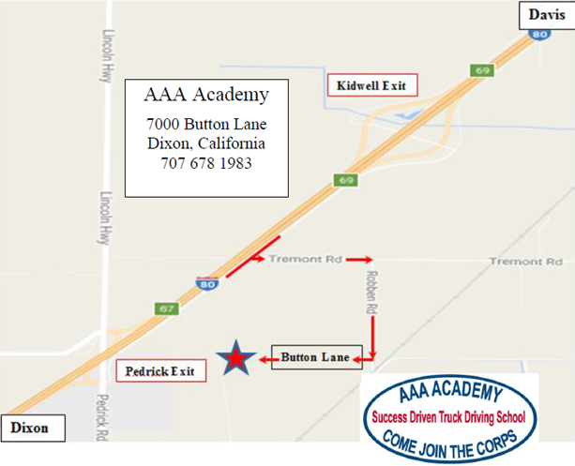

AAA Academy Equipment. AAA Academy operates Class A trucks with trailer for skills training, on-road practice, and DMV testing. It is a comparable vehicle to the type of equipment a student would drive professionally.
    - Truck and Trailer Specifications.
Truck: 2 - 2011 Volvo three-axle 10 speed day-cab.
3 - 2011 Volvo three-axel 10-speed sleeper units.
Trailer: 4- 22 ft. single axle trailers.
1- 28 ft. dual axle Cargo Container Trailer.

AAA Academy Facility
within
Button Transportation

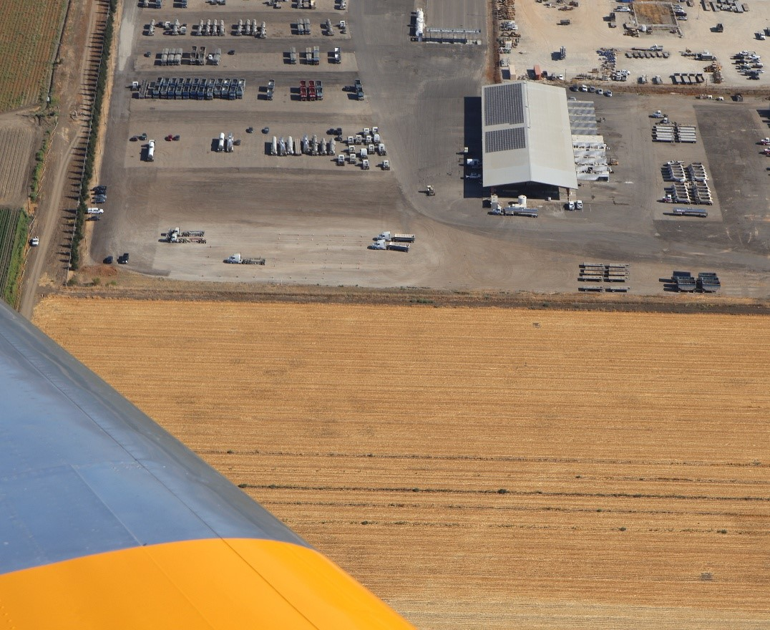
Skills Range Area
AAA Academy Library. The library, located in AAA Academy’s Training Room, is available to all students during regular business hours, 8am to 5pm. It includes a complete collection of DMV driver manuals, AAA Academy’s training materials and a computer for web-accessing information. There is no cost for the use of any learning materials. All DMV manuals are provided to AAA Academy students at no charge. For access, simply ask one of our instructors. They will assist you in finding information to address your question.
Skills Range Area

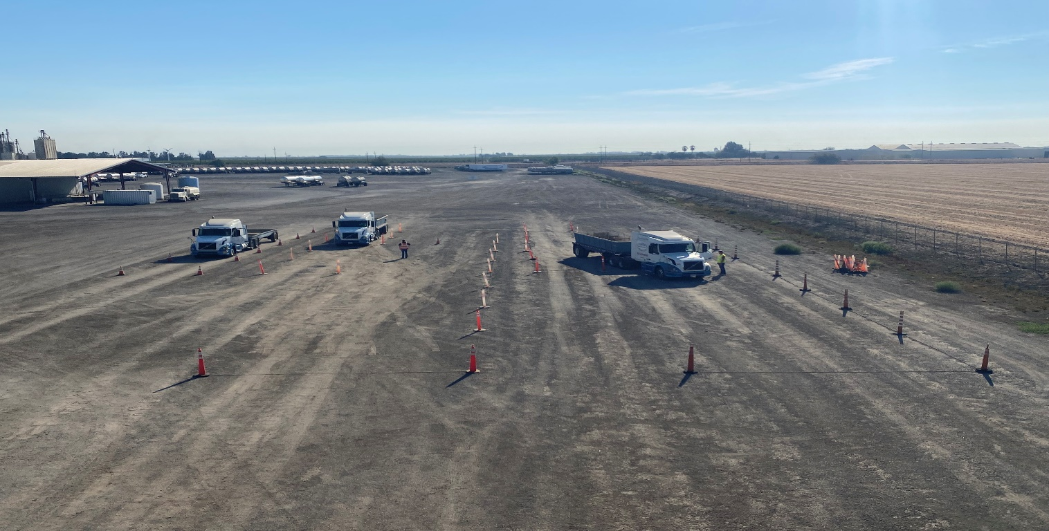
Skills Range Area
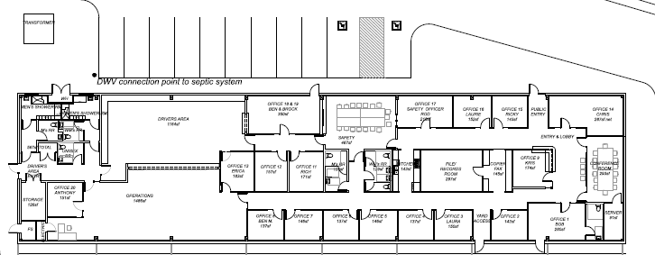
Training Room & Library
AAA Academy
Training Room & Library

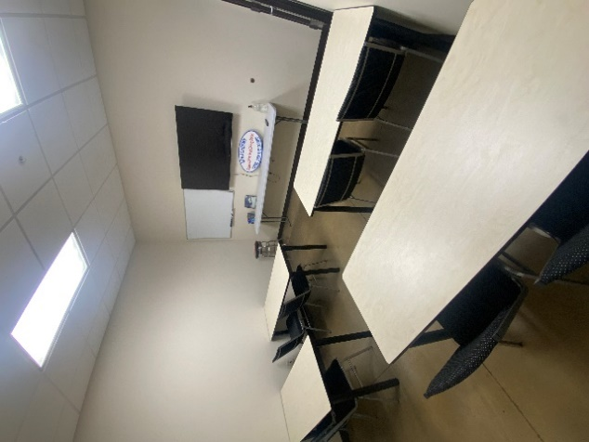

Student Services. AAA Academy offers no additional student services beyond the vocational training outlined herein.
Housing Information. AAA Academy is a non-residential training program. It has no dormitory facilities under its control. AAA Academy provides training for those who live in the general vicinity of the facility. AAA Academy makes no claim or promise, to find or assist any student in finding housing. There are lodging facilities within five miles of the training facility with rooms available from $80 to $100 per night. Should a student require motel accommodations, he or she will have to make these arrangements independently. AAA Academy tuition DOES NOT Include lodging, room, or board by any definition.
Student Records Policy. AAA Academy will permanently retain transcript records for each student. All other student records will be maintained for a minimum of five (5) years. After that, the records may be available, but it is not guaranteed. Please note: AAA Academy only offers training for persons to obtain their Class A Commercial Driver License (CDL). The certificate one receives on completion of AAA Academy’s training is in - itself of no value, nor is it transferable or otherwise useful or beneficial. What is of value is the knowledge the student gains, which may result in Commercial Driver Licensure. As such, student records are relevant only as proof of attendance and licensure for Third Party Payees, BPPE review and potential employers.
Background. AAA Academy admitted its first class of students July of 2018. It is important to note that none of these students were charged for the training. AAA Academy provided training to approximately three dozen students at no charge, with the understanding that they would work for either Button Transportation or Benjamin’s Transfer for the balance of 2018 at Full Wage and Benefit. (Please note: Full Wage and Benefit means, these newly coined Class A drivers were paid exactly, the same as every Class A driver employed with Button Transportation and Benjamin’s Transfer. Nothing was held back from their wages or benefits to compensate for the costs associated with their commercial driver training.) This arrangement was a soft, “gentlemen’s agreement,” meaning the student was in no way obligated, contractually, or otherwise required to work with Button Transportation or Benjamin’s Transfer. Approval to operate was granted by BPPE on April 2, 2019. Approval to operate means that the institution is compliant with the minimum standards contained in the California Private Postsecondary Education Act of 2009 (as amended) and Division 7.5, Title 5 of the California Code of Regulations.
Other truck driving schools “graduate” students, some of whom do not ultimately earn their Class A, Commercial Driver License. This can only be acknowledged as a half-measure. Commercial driver licensure and student employment are the measurements of AAA Academy’s success. And, as our slogan states in our corporate logo, “AAA Academy (is a) Success Driven Truck Driving School.”
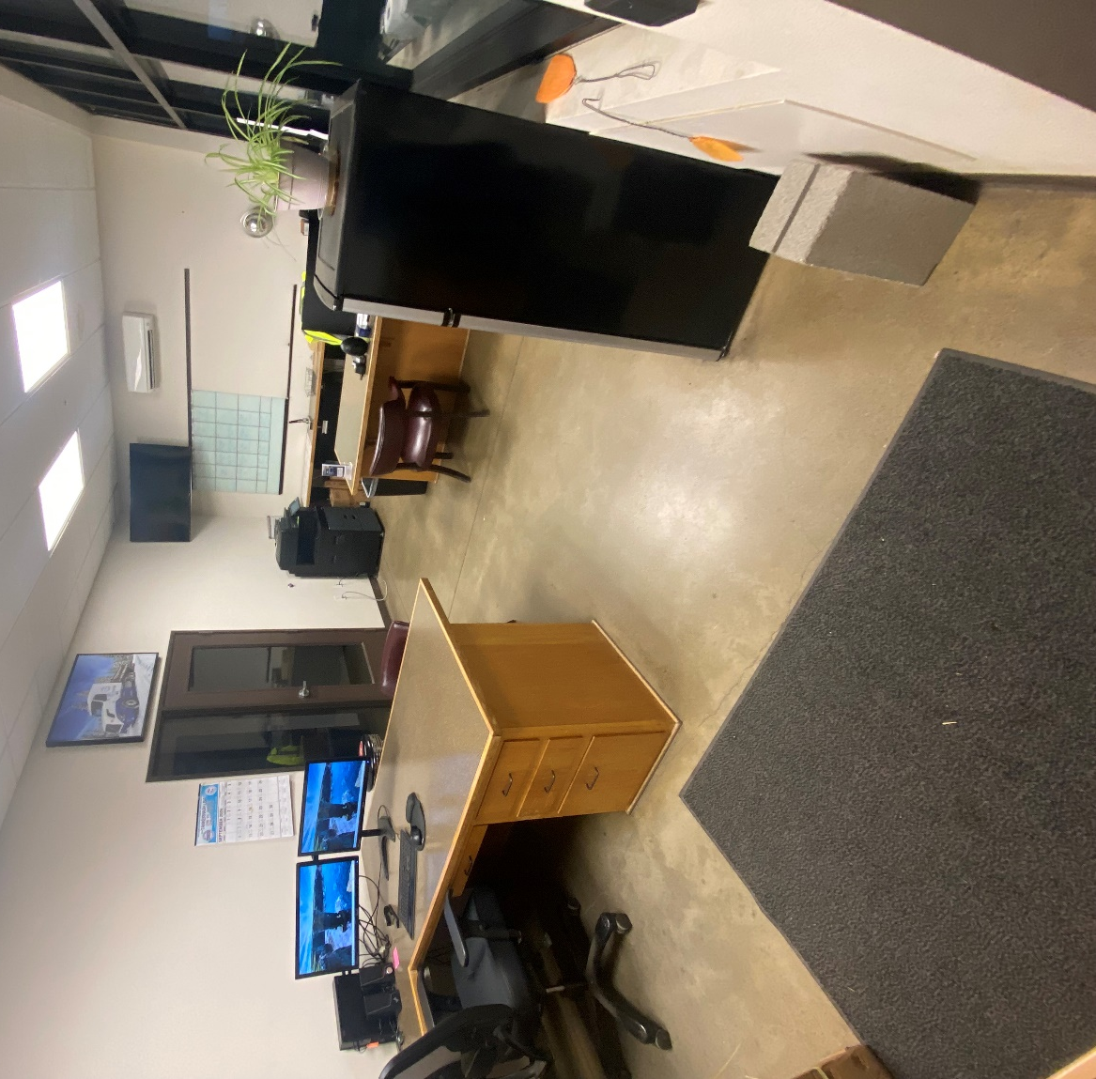
AAA Academy Office

